Vietnam War
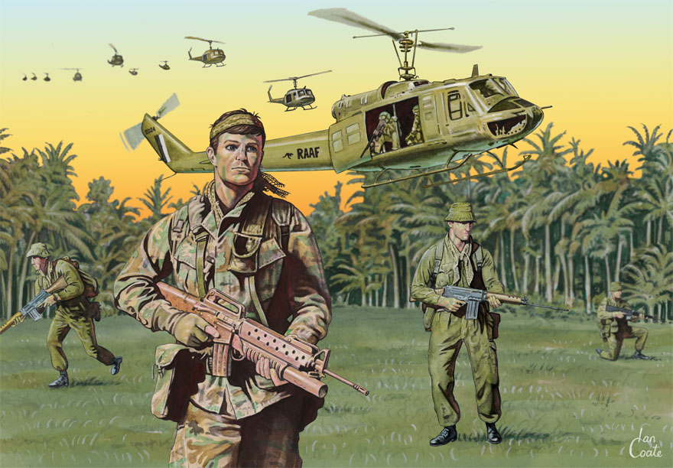
Books : ebooks : Clickview : Websites
Bibliography
Dewey Number : Vietnam War : 959.7043
Books
909.82 ADA Adams, Simon 20th Century - A Visual History, (Banksia Junior Library)
909.82 GIL Gilligan, Beth Twentieth century studies : the struggle for freedom, (Acacia Senior Library)
973.9 AME Torr, James D Americans' views about war, (Banksia Senior Library)
Australian’s at war
355.00994 MAC Macdougall, A.K The peace keepers : Australia at war since 1945, (Banksia Junior/Senior Library)
940.426 LEW Lewis, Robert Home fronts at war : the Australian experience of war in World War 1, World War 2, and the Vietnam War : evidence and activities, (Acacia Senior Library)
940.426 SAD Sadler, Rex In the line of fire : real stories of Australians at war, from Gallipoli to Vietnam, (Acacia Senior Library)
994.04 BLA Blackmore, Wes Australians and war, (Acacia Junior Library)
994.04 BLA Cochrane, Peter Australians and war, (Banksia Senior Library)
994.04 MCD Macdougall, A.K Australians and war: a pictorial history, (Acacia Junior/Banksia Senior Library)
Ebooks
ebooks from the State Library to access these resources Become a Library member
Clickview
Australia: The Story Of Us: Episode 8 of 8
Australia and the Vietnam War
The Australian experience : A Black & White War?: Australian Involvement in the Vietnam War
Australian History 2/2
Australian Migration (1945 Onwards) - Post WWII
Australians at War 7/8 : Trying not to remember
Australians in Vietnam
The Battle of Long Tan
Cold War (Make love not war; The Sixties : Vietnam 1954 – 1968)
Conflict in Indochina: Post WWII
The crater : a Vietnam War story
Indochina: a people's war in colour: then the Americans came
Vietnam Before The War with America
Vietnam War : a decent into hell series
Websites
Study Guide : Lesson Plans : PowerPoint : Quizzes : Teachertube

Vietnam War from World Book Encyclopaedia (Username: kscab – Password: student)
Australian War Memorial Encyclopedia
Summary
Vietnam War: 1962-1972 from the Australian War Memorial
Study Guide
Australia & the Vietnam War
Australia and the Vietnam War from the Centre for Learning Innovation
Australia’s involvement it the Vietnam War
Sparke Notes Study Guide
Vietnam Centre & Archive
Vietnam War from PBS
Vietnam War from History Place
War Remnants Museum Ho Chi Minh City
List of Links to Websites
Vietnam War List of Links to Websites
Lesson Plans & Worksheets
Anzac Day Activities
Australia/Vietnam War
Teaching with Documents
Vietnam: the soldier’s experience
VCE Attitudes to the Vietnam War from the Shrine of Remembrance
PowerPoint
Vietnam War from Slideshare
Primary Sources
Vietnam War from Pinterest
News articles from the State Library
Quizzes
Vietnam War from Quizlet
Women
Women in Vietnam
Teachertube & Video’s
Vietnam War from Teachertube
Vietnam War from Australian Screen
Vietnam War From ACMI

